**AMR Burden of Travel**

*These notes introduce some introductory thinking on how to analyse the role of travel in the spread of AMR strains.*

*All travel flows are calculated at the country level then aggregated to regional level. Resistance burden calculations done at the regional level based on regionally aggregated country-level resistance data from Lancet paper. Obviously, all these calculations need to be done at a country level.*

**John J Beggs**

**Peter Collignon**

**17 May 2024**

**Background**

To analyse how human travel influences the spread of antimicrobial-resistant germs globally, we need to map out travel patterns. While we have data on people’s movements across borders, the detailed interactions between specific country pairs are not well-documented. Our study proposes using a trip distribution gravity model to estimate the flow of travellers between these pairs.

The gravity model, which has been a staple in transportation, trade, and migration studies since the 1960s, is based on the principles of Newtonian gravity. It suggests that the interaction between two locations diminishes with distance but increases with the size of the locations involved. The model was first pioneered by Zipf (1946) to examine inter-city travel in the USA. The Dutch economist Tinbergen (1962) used the model to study global trade flows, and Anderson (1979 and 2010) developed further the theoretical economic underpinnings of the model. Wilson (1967) motivated the model as the entropy maximizing solution of a statistical mechanics formulation of patterns in intra-urban trip distribution. Despite its popularity, it wasn’t until the 2000s that this model saw a resurgence in tourism research. An extensive survey of recent research has been provided by Nadal and Gallego (2022).

In our context, travel between countries is determined by their ability to generate or attract travellers which is measured by the number of tourists departing from and arriving at each destination. ‘Distance’ can encompass not only physical space but also factors like language connectivity, travel costs, and ease of crossing borders, however, as a practical matter, physical distance is the metric most used. Nadal and Gallego cite that distance is included in 88% of the relevant research papers they surveyed, whilst travel costs are less frequent and only considered in 7%.

**Gravity Model**

The application of the gravity model used in this research is formulated as a series of simple equations. Firstly, we define the attractiveness of destination country j for travellers departing from country i to be measured as:

The parameter determines the sensitivity of travel to distance. The number of travellers from i going to j is then estimated allocating departures proportionally according to relative attractiveness of destination j versus all other possible destinations:

K is a scaling factor that must account for the fact that persons departing from i may visit more than one destination.

**Data**

Data on outbound and inbound travel are available for tourism using the World Tourism Statistics Database [ref] for 241 countries. This study uses data for 2019 which is the year with the most complete dataset, and it predates the temporary disruptions to travel created by the Covid pandemic. Data on inbound tourism is more complete than for outbound travel. Usable data was available for the number of inbound tourists for 191 countries, and countries with missing data were both small and low incomes and consequently unlikely to be materially important on a global scale.

Departure data was only available for 100 countries, and statistical estimates of outbound travel were generated for the 91 countries with missing data. We regressed outbound data of travellers per capita for the 100 countries with available data against those country’s GDP per capita. The data fit is shown in the figure below and has an R-squared of 71.4%. The resulting equation generated predictions of outbound travel for the 91 countries with missing data. These statistically generated data accounted for 12.5% of the total global outbound travel.

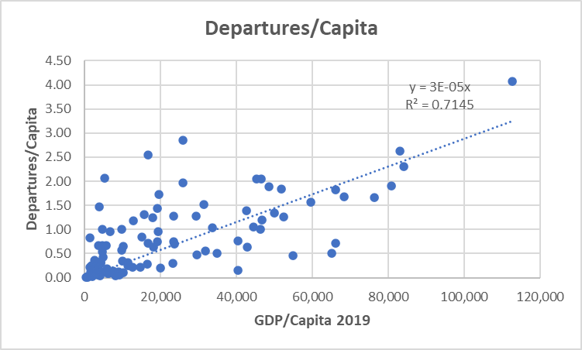

Total country inbound arrivals will be larger than outbound departures because some travellers will visit more than one country. In these data, arrivals numbers exceed departures by 29%. Hence the coefficient k in equation (2) has been set at 1.29.

The parameter that determines the sensitivity of travel to distance needs to be estimated from data, but no comprehensive set of pair-wise global travel data are available. The parameter is sometimes referred to as the elasticity of travel with respect to distance. It is an exercise in elementary calculus to show that measures the percentage change in attractiveness with respect to a one percentage increase in the distance between two points. There are many other published studies that have reported estimates for tourist travel and the survey article by Nadal and Gallego report usable estimates from 94 published studies. Data are shown in the Appendix. The usable data shows a lot of variability among the elasticity estimates, but for this analysis we have adopted the simple average which sets at 1.01.

Distances between country pairs were formed using country geographical-central co-ordinates available from Dataset Publishing Language and published by Google. Distances were then obtained using the Haversine formula. All distances less than 100 kilometres are set to 100 kilometres to account for some minimum get-underway costs of any inter-country travel. This minimum was required for only 18 of the 18,146 country pairs in the data set.

**Trip Distribution**

Inbound and outbound travel was distributed across 191 countries according to the formulae shown above. Results are available as a 191x191 matrix in the Supplementary spreadsheet. A regional summary of the 2.3 billion annual inbound arrivals is provided in the table below in thousands per year.

**Table 1: Estimated Inbound and Outbound Tourist Numbers 2019 (Thousands**)



**Table 2 Relative size of the inbound and outbound travel for each region.**



**AMR Burden Generated by Travel**

When residents travel abroad, they can transmit novel infection to the countries they visit, and they can also carry home infection they have acquired on their travel. Visitors from countries with a high incidence of AMR infection will likely raise the infection rate in the countries they visit. Conversely, residents who visit regions with high rates of resistant infection will risk carrying novel infections on their return home.

In the following section we begin to make initial estimates for the AMR burden of travel using regional flows of people. Clearly this analysis can be extended down to a country level in the near future especially with better data on resistance rates.

First considering inbound visitors, denote

Where here l and k are numbered 1 to 19.

If the AMR of the average visitor is greater than one, then the average visitor comes from a country with a higher rate of AMR than is in the host country. This measure is calculated as relative burden of AMR can then be measured as

Similarly, we can define the burden imposed by returning travellers. Results are shown in Tables 3 and 4 below.

**Table 3: Relative AMR Burden Generated by Average Inbound Visitor**



**Table 4: Relative AMR Burden Generated by Average Returning Outbound Traveller**



To calculate the AMR burden of travel, it is necessary to reflect the total number of tourists coming into a region relative to the population size of the region is also important. Small regions with large numbers of inbound tourist inevitably generate relatively more person-to-person opportunities for the transfer of resistant genes than does a small number of tourists entering a very large country. We calculate thus:

Similarly, we can define the burden for returning travellers.

Results are shown in Table 4 for both arriving visitors and returning travellers for E.coli and MRSA where missing data country-level resistance data was filled with averages.

Figure 6 provides a map of the regional boundaries, and Figures 7 to 10 map the data in Figure 5 above. On the maps relative AMR burdens above 1.5 are shown at 1.5 to facilitate the graphing software.

**Figure 5: Relative Regional AMR Burden**

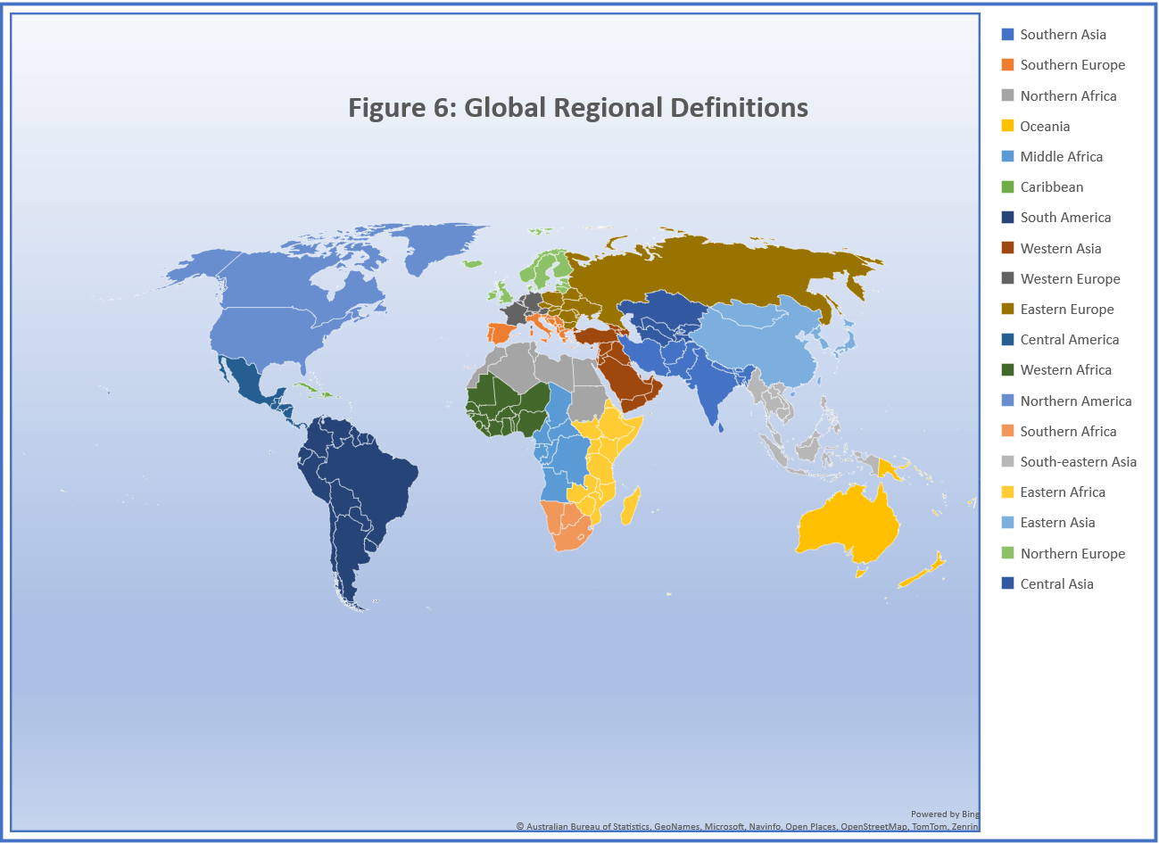

**Some References**

World Tourism Organization (2023), UNWTO Tourism Statistics Database, Madrid, data updated on 25/01/2023. <https://www.unwto.org/tourism-statistics/tourism-statistics-database>

Wilson, A. G. (1967). *A statistical theory of spatial distribution models*. Transportation Research, **1**, 253–269.

Tinbergen, J. (1962). *Shaping the world economy: Suggestions for an International Economic Policy*. The Twentieth Century Fund.

Zipf, G. K. (1946). *The P1P2/D hypothesis: On the intercity movement of persons*. American Sociological Review, **11**(6), 677–686.

Anderson, J. E. (1979). *A theoretical foundation for the gravity equation*. American Economic Review, **69**, 106–16

*The Gravity Model*, James E. Anderson Working Paper 16576 http://www.nber.org/papers/w16576 NATIONAL BUREAU OF ECONOMIC RESEARCH 1050 Massachusetts Avenue Cambridge, MA 02138 December 2010

Geographic Canonical Concepts <https://developers.google.com/public-data/docs/canonical/countries_csv>

*Antimicrobial resistance: a global public health emergency further exacerbated by international travel* Marisa Holubar Journal of Travel Medicine, Volume 27, Issue 1, January 2020, taz095.

*The afterlife of antibiotics* Mary E. Wilson Journal of Travel Medicine, Volume 27, Issue 1, January 2020, taz102.

*Global geographic trends in antimicrobial resistance: the role of international travel*, Isabel Frost, Thomas P Van Boeckel, João Pires, Jessica Craig, Ramanan Laxminarayan, Journal of Travel Medicine, Volume 26, Issue 8, 2019, taz036.

*Risk factors for acquisition of multidrug-resistant Enterobacterales among international travellers: a synthesis of cumulative evidence* Luis Furuya-Kanamori, Jennifer Stone, Laith Yakob, Martyn Kirk, Peter Collignon, Deborah J Mills, Colleen L Lau Journal of Travel Medicine, Volume 27, Issue 1, January 2020, taz083.

*Antibiotic resistance patterns of Escherichia coli in migrants vs non-migrants: a study of 14 561 urine samples* Louise B Sloth, Rikke T Nielsen, Christian Østergaard, Laura B Nellums, Sally Hargreaves, Jon S Friedland, Marie Norredam Journal of Travel Medicine, Volume 26, Issue 8, 2019, taz080.

*How are travellers colonized with antimicrobial-resistant bacteria?* Sebastian Wendt, Paul Böhm, Jonas Daniel, Norman Lippmann, Christoph Lübbert Journal of Travel Medicine, Volume 27, Issue 1, January 2020, taz068.

